POWERED BY
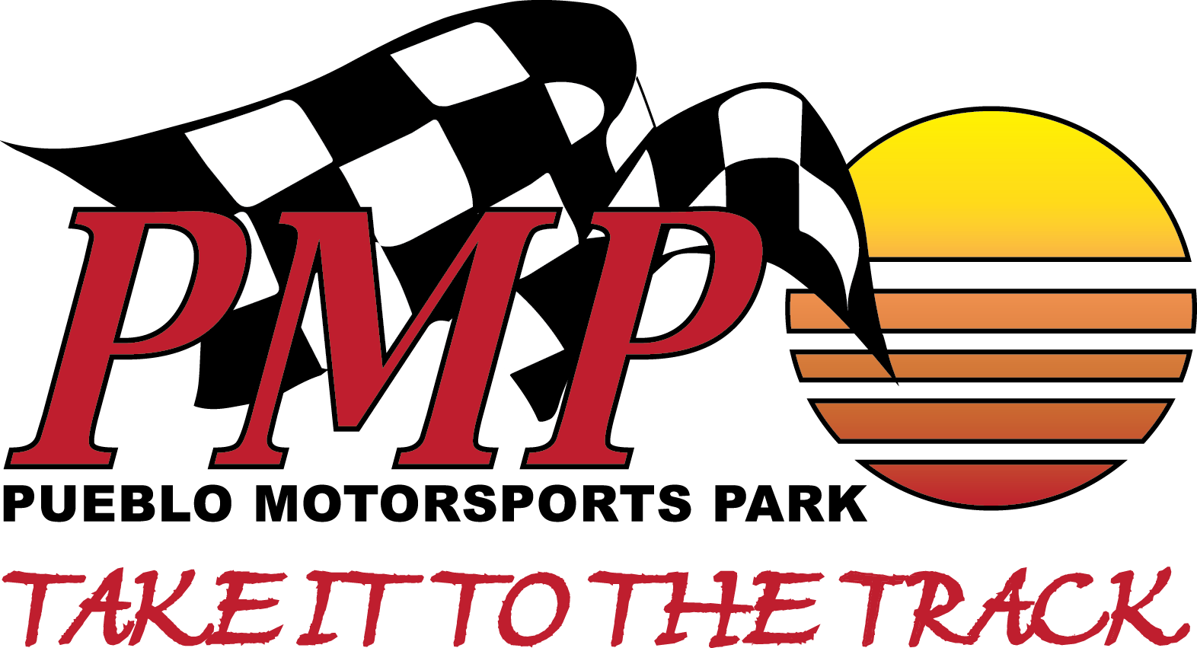
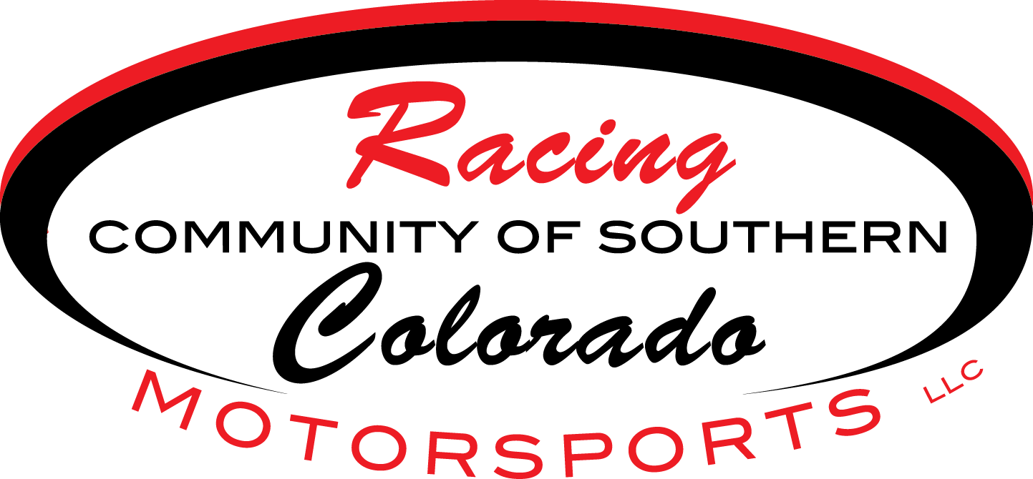

PUEBLO MOTORSPORTS PARK
SPONSORSHIP LANE 2018 SEASON

WE INVITE YOU….To take advantage of a great marketing opportunity and get your business seen by our dedicated and enthusiastic drivers & spectators all season long! We have over 140 events pre-scheduled including Drag Races, Road Course races, Motorcycle, Mud Drags, Motocross (soon) and don’t forget the growing number of spectators. There are a variety of packages to choose from!
So let’s partner up and ‘TAKE IT TO THE TRACK!’
DIAMOND SPONSOR $12,000 (1 Available/Per Season)
- 2018 Season Lane Scoreboard Named after your business!
- Business Name printed on ET Tickets for Drag Racers for entire season
- 4 Premier locations in high traffic areas for your Logo Banners (sponsor section) - size negotiated, best possible location/s
- 2 Exclusive Event FND (Friday Night Drags) Sponsored Nights including…
- VIP Room for up to 42 persons (deli sandwiches / drinks provided) during the above pre-scheduled FND event
- Booth Space: can provide awning and picnic table or space near drag strip for on-site advertising during as many events as negotiated
- On-Site Broadcast including MULTIPLE COMMERCIAL SPOTS several times during all Drag race events
- Social media blasts throughout season – written by sponsor (Facebook & Websites)
- Radio ad “Sponsored By” blasts for events
- Diamond level logo included on event branding such as T-shirts and flyers
- Rolling banner on Website for Season
- 20 FREE spectator tickets / NOT TO INCLUDE RACERS FEES
PLATINUM SPONSOR $10,000 (1 Available/Season)
- 2018 Season Lane Scoreboard Named after your business!
- 4 Premier locations in high traffic areas for your Logo Banners (sponsor section) - size negotiated, best possible location/s
- 1 Exclusive Event FND (Friday Night Drags) Sponsored Night including…
- VIP Room for up to 42 persons (deli sandwiches / drinks provided) during one pre-scheduled FND event as available
- Booth Space: can provide awning and picnic table or space near drag strip for on-site advertising during as many events as negotiated
- On-Site Broadcast including MULTIPLE COMMERCIAL SPOTS several times during all Drag race events
- Social media blasts throughout season – written by sponsor (Facebook & Websites)
- Radio ad “Sponsored by” blasts for event/s sponsored
- Platinum level logo included on event branding such as T-shirts and flyers
- Rolling banner on Website for Season
- 15 FREE spectator tickets / NOT TO INCLUDE RACERS FEES
GOLD SPONSOR $5,000 (2 Available/Season)
- One Event FND (Friday Night Drags) Exclusive sponsorship Night evening for up to 42 persons
  - We provide meal trays and drinks for above night
- On-site presence Banner/s (sponsor section) size and quantity negotiated, best possible location/s
- Social media blasts throughout season – written by sponsor (Facebook & Websites)
- On-Site Broadcast including MULTIPLE COMMERCIAL SPOTS several times during the event
- Radio ad “Sponsored by” blasts for event/s sponsored
- Rolling banner on front page of Website for Season
- Signboard Logo next to Concessions & One Event FND (Friday Night Drags) Exclusive Sponsorship Night *
- GOLD level logo/Ad included on event branding such as T-shirts and flyers
- Booth Space: can provide awning (as available – higher level sponsors receive priority) and picnic table or space near drag strip for on-site advertising during as many events as negotiated
- 15 x FREE spectator tickets / NOT TO INCLUDE RACERS FEES
SILVER SPONSOR $2,500 (0 Available/Season)
- One Event FND (Friday Night Drags) Exclusive sponsorship Night evening includes VIP Room use for up to 42 persons
  - We provide meal trays and drinks for above night
- Social media blasts throughout season – written by sponsor (Facebook & Websites)
- On-Site Broadcast including MULTIPLE COMMERCIAL SPOTS several times during the event
- Radio ad “Sponsored by” blasts for event/s sponsored
- On-site presence Banner (sponsor section) size negotiated, best possible location/s
- SILVER level logo included on event branding such as T-shirts and flyers
- Booth Space: can provide awning (as available – higher level sponsors receive priority) and picnic table or space near drag strip for on-site advertising during as many events as negotiated
- 10 x FREE spectator tickets / NOT TO INCLUDE RACERS FEES
BRONZE SPONSOR $1,500 (4 Available/Season) 2 remaining
- One Event FND (Friday Night Drags) Shared sponsorship Night if availability allows
- VIP Room use for the FND Shared Sponsored evening for up to 21 persons each during above FND
- On-site presence/ Banner (sponsor section) size negotiated, best possible location/s
- Social media blasts throughout season – written by sponsor (Facebook & Websites)
- On-Site Broadcast including MULTIPLE COMMERCIAL SPOTS several times during the event
- BRONZE level logo included on all event branding in high traffic areas
- Booth Space: can provide awning (as available – higher level sponsors receive priority) and picnic table or space near drag strip for on-site advertising during as many events as negotiated
- 5 x FREE spectator ticket / NOT TO INCLUDE RACERS FEES
EVENT PAYOUT SPONSOR (12 Available/Season)
- Be the HERO of the race day! The payouts are the very important to the racers. The higher the numbers, the more racers notice and share the information with family and friends on social media, and there is an increased appreciation to the sponsor!
- The total race payout is $2600.00 per race. The race event is yours to claim as the Full Sponsor, or to share with others – your call on how much you want to donate to a race.
- This allows the sponsor to be creative and combine packages or design his or her own. Let’s Talk!
ADVERTISING INFORMATION

Custom packages can be created to meet the needs and budget of Sponsor. We want to help you with your business as well as have you support ours!

- Banners and Promotional Items to be provided by Sponsors. Banners are suggested to be of higher quality material to withstand the high winds Pueblo offers!
- Designing services and printing options can be provided
- Banners and advertisements must be preapproved by management prior to print.
- Remember: All Packages are subject to availability on a first-come, first-serve basis.
RACETRACK INFORMATION

We always welcome input, requests, and suggestions to make PMP the best Motorsports Park in Pueblo!
Donations are welcome for any complete or partial areas of need.

- Additional Spectator Bleachers  - Playground &/or Playground equipment  - Pergolas for road course corner workers  - Cover for handicap area | A shower facility  Beer Garden  Electrical Hookups for campers  Road Safety Cones – all sizes  Small trailer for 4-wheelers

